<https://docs.spring.io/spring-boot/docs/2.5.6/reference/html/actuator.html>

metrics are available here

Actuaters

Prometheus – dependency used for monitoring our project

Whitelabel error page – on our config only publicurls are permitted

The error occurs when the components are not explicitly declared.

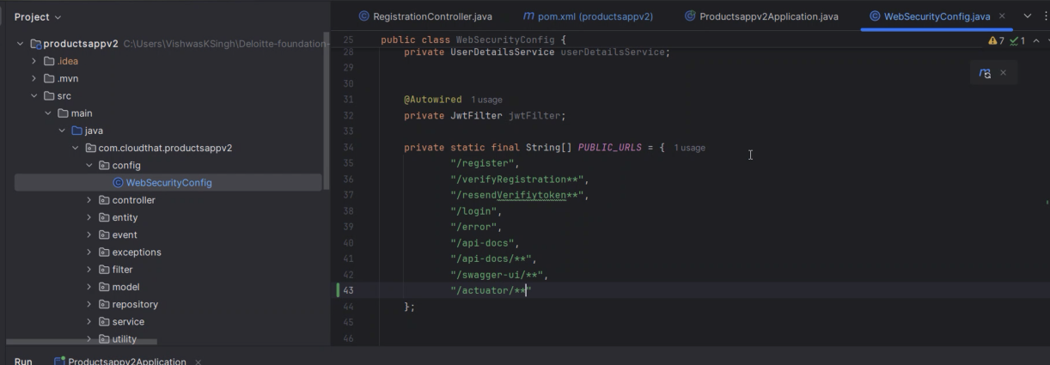

Here just added dependency it but itz not a good practice. (/actuator)

<http://54.161.97.93:5000>

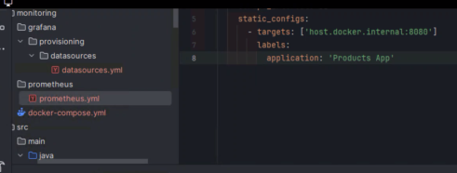

First register user using thunderclient

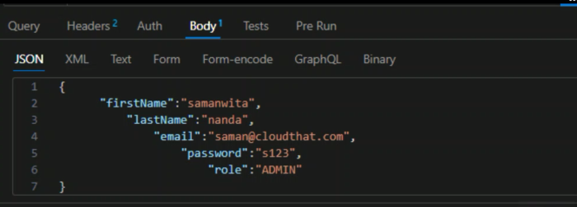

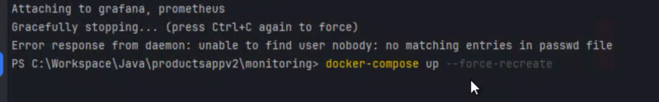

But it will show error if its error

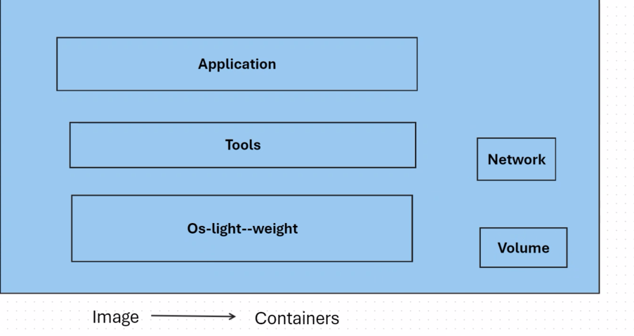

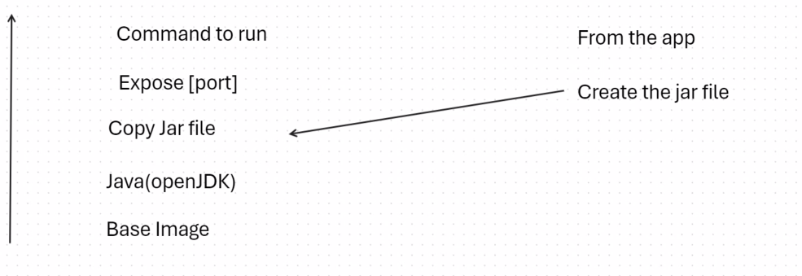

Basically we have multiple layers

Create a dockerfile in ur project root foler i.e where the pom.xml file is located

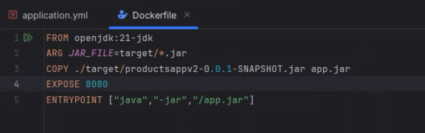

Expose port, copying the jar file as app.jar

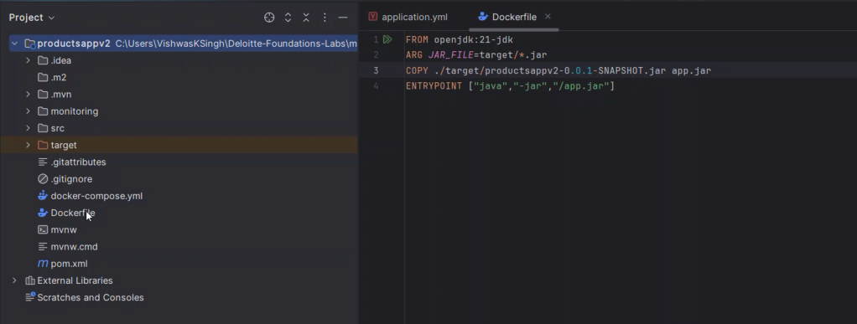

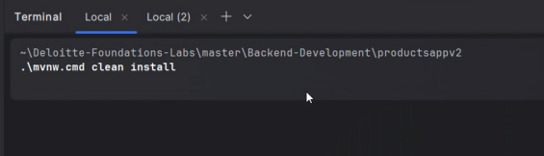

Maven wrapper clean install

Compiles everything and created the jar file for us

Then have to run the build command : docker build -t productsapp:latest .

Open jdk-21 alpine is the latest version.

CASE STUDY

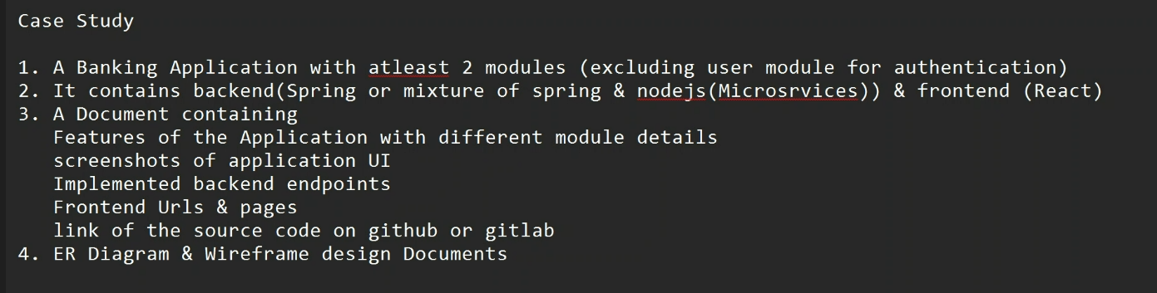



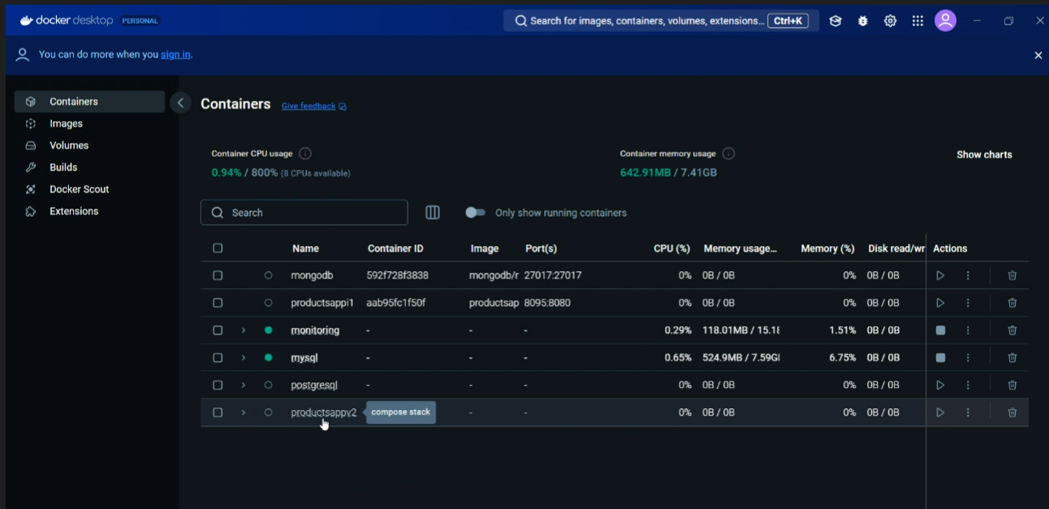

For running

Docker-compose up

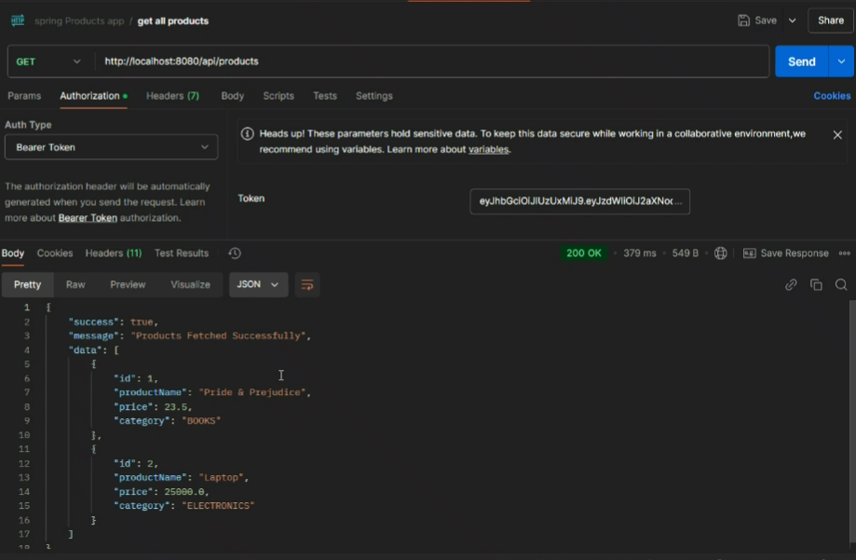

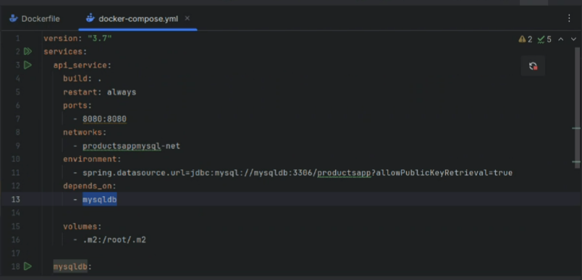

<https://docs.spring.io/spring-boot/docs/1.2.0.M1/reference/html/boot-features-profiles.html>

<https://docs.spring.io/spring-boot/docs/1.2.0.M1/reference/html/howto-properties-and-configuration.html#howto-change-configuration-depending-on-the-environment>

<https://www.metricsthatmatter.com/url/u.aspx?F17675F85215981118>

<https://spring.io/guides>

<https://spring.io/microservices>